[What is Thingspeak?](https://thingspeak.com/)

[**ThingSpeak**](https://thingspeak.com/)is an [IoT analytics](https://www.mathworks.com/solutions/internet-of-things.html) platform service that allows you to collect and then aggregate, visualize, and analyze live data streams in the cloud.

* send data to ThingSpeak™ from your devices (sensors)
* create instant visualizations of live data,
* send alerts using web services like Twitter® and Twilio®.

**ThingSpeak** enables engineers and scientists to prototype and build IoT systems without setting up servers or developing web software.

**ThingSpeak** is free (except for commercial use). All that is needed is a Thingspeak Account.

Sign up for an account

* Login to my Router
* Virusgenerator
* Password: VGAquarius090317

**Create a Thingspeak Account**

Open your gmail account. Thingspeak will send verification to it during registration.

Go to url Thingspeak.com

Click Get Started for Free

**Click create account**. Fill up this registration form.

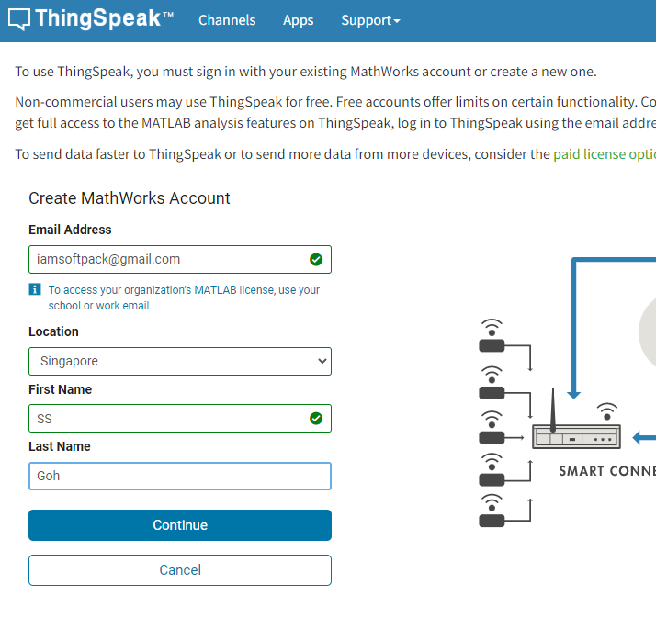

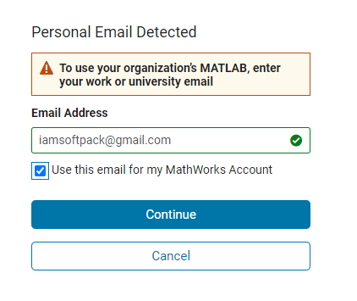

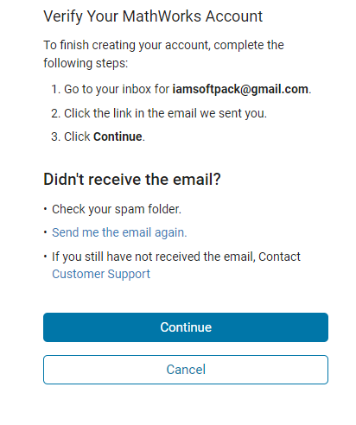

Go to your gmail account

Open the email from Thingspeak and Verify Email

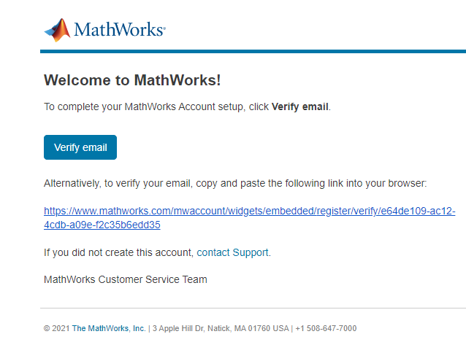

You should get a confirmation like this

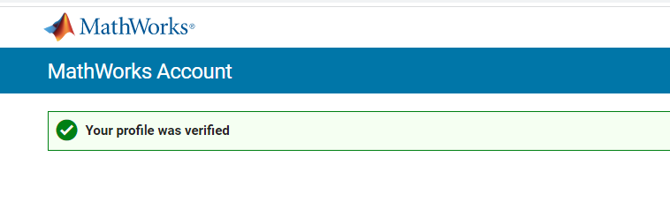

Go back to Account Setup Page and create password to finish Profile

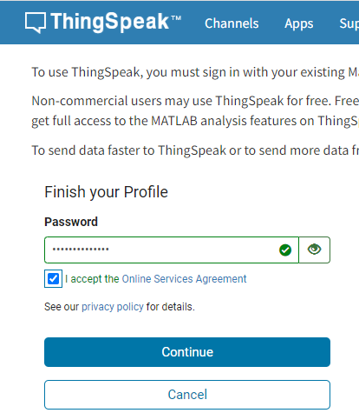

**Creating a channel**

Channel ID and API Keys